Borehole No. Exploration Borehole No 2
Location APDO Tease, Afram Plains
Latitude N06°56.121’
Longitude W00°14.997’
Date started 01/05/2001
Date completed 03/05/2001

Summary Lithological Log
Depth(m)
From To

0 2 Soil/laterite
2 4.1 Soft silty sandy clay
4.1 7.1 Soft sandy clayey silt
7.1 18.3 Soft fine sandy silty clay
18.3 30.5 Soft to very weathered sandy clayey silt
30.5 34.5 Weathered medium grained sandstone with quartz pebbles
34.5 39.6 Very to fairly weathered medium grained sandstone with gravel
39.6 55.9 Fairly weathered medium grained sandstone
55.9 75.2 Fairly weathered medium grained sandstone with gravel bands
75.2 82.3 Fairly weathered medium grained sandstone
82.3 86.4 Slightly weathered to fairly hard siltstone
86.4 90.4 Fairly hard shale and fine grained sandstone
90.4 103.6 Fairly hard fine grained sandstone
103.6 107.7 Fairly hard very fine grained sandstone to siltstone
107.7 111.8 Fairly hard fine grained sandstone to siltstone
111.8 125 Fairly hard siltstone to mudstone
125 131.1 Fairly hard siltstone to very fine grained sandstone
131.1 133.1 Fairly hard very fine grained sandstone
133.1 141.2 Fairly hard very fine grained sandstone to siltstone
141.3 143.3 Fairly hard very fine grained sandstone
143.3 150.4 Fairly hard very fine grained sandstone to siltstone
150.4 152.4 Fairly hard siltstone

Comments on Water Production Zones
First water struck is a small amount of water (16 l/min) at 45m in fairly weathered sandstones just below the base of the very weathered zone.
Flow rate diminishes to 10 l/min by 74m due to smearing of borehole sides with fine sand
Fracture zone marked by calcite veining at 90-91m produced 20 l/min increased to 60 l/min by 92 with increased submergence.
Veining at 98-99m but no obvious increase in flow
Veining at 106m with increase in flow to 92 l/min by 108m
Veining at 111m
Flow rate decreased to 85 l/min by 116m due to borehole smearing
Flow rate increased to 130 l/min by 136 but no apparent inflow zone, some calcite between 134-136m

Detailed Photo-lithological Log

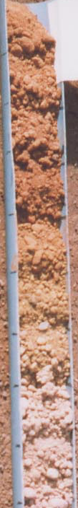
Depth(m)

0.0-1.0 5YR 4/6 yellowish red sandy clayey lateritic topsoil.

1.0-2.0 5YR 4/6 yellowish red sandy very clayey lateritic topsoil.

2.0-3.0 5YR 4/6 yellowish red and some 2.5YR 4/8 red sandy silty clay.

3.0-4.1 2.5YR 3/6 dark red silty sandy clay. (Dark red brown, orange yellow, ochre and white soft very weathered sandstone/ferrecrete with some clay)

4.1-5.1 5YR 4/6 yellowish red silty sand with 10YR 6/8 brownish yellow and 10YR 7/2 light grey clay.

5.1-6.1 7.5YR 4/6 strong brown sandy clayey silt.

6.1-7.1 7.5YR 5/6 strong brown sandy clayey silt with some weathered dark red medium sandstone.

7.1-8.1 7.5YR 6/6 reddish yellow with 5YR 4/6 yellowish red and 7.5YR 7/1 light grey silty clay.

8.1-9.1 7.5YR 6/6 reddish yellow with 7.5YR 7/1 light grey and a little 5YR 4/6 yellowish red silty clay.

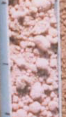

9.1-10.2 5YR 5/6 yellowish red with some 10YR 6/8 brownish yellow sandy silty clay.

10.2-11.2 2.5YR 5/6 reddish brown with gley 1 8/1 light greenish grey sandy silty clay.

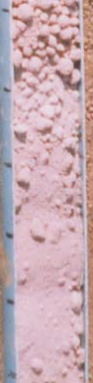
11.2-12.2 2.5YR 5/6 reddish brown with gley 1 8/1 light greenish grey sandy silty clay.

12.2-13.2 2.5YR 5/4 reddish brown with some 2.5YR 8/2 pinkish white silty sandy clay.

13.2-14.2 2.5YR 5/6 red fine sandy clayey silt. Some 5YR 3/2 dark reddish brown silty clay.

14.2-15.2 2.5YR 5/6 red fine sandy clayey silt.

15.2-16.3 2.5YR 5/4 reddish brown fine sandy silty clay.

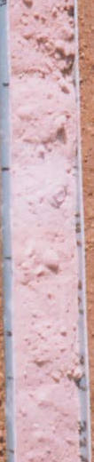

16.3-17.3 2.5YR 5/4 reddish brown fine sandy silty clay.

17.3-18.3 2.5YR 5/4 reddish brown with some 2.5YR 4/3 reddish brown silty clay.

18.3-19.3 2.5YR 6/4 light reddish brown fine sandy clayey silt.

19.3-20.3 2.5YR 5/4 reddish brown clayey silt. Some fine sand.

20.3-21.3 2.5YR 6/4 light Reddish Brown clayey silt. Some fine sand.

21.3 22.4 2.5YR 5/6 red sandy clayey silt.

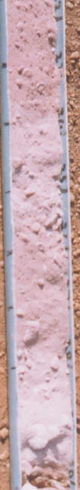

22.4-23.4 2.5YR 4/4 reddish brown sandy clayey silt.

23.4-24.4 2.5YR 5/6 red sandy clayey silt with a very little very highly weathered dark red sandstone, which has numerous fine dark grains apparent when wet. (Grey red clayey sandy siltstone, very soft)

24.4-25.4 2.5YR 5/4 reddish brown clayey sandy silt with some very highly weathered dark red sandstone.

25.4-26.4 2.5YR 5/3 reddish brown sandy clayey silt with very highly weathered light grey and dark brown sandstone.

26.4-27.4 2.5YR 5/6 red sandy clayey silt with very highly weathered light grey and dark brown sandstone.

27.4-28.4 2.5YR 5/6 red sandy clayey silt with very highly weathered light grey and dark brown sandstone.

28.4-29.5 2.5YR 5/4 reddish brown clayey sandy silt with some highly weathered dark brown medium sandstone.

29.5-30.5 2.5YR 6/4 light reddish brown clayey sandy silt with some highly weathered dark brown and pale grey medium sandstone.

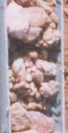

30.5-31.5 Fairly weathered dark red, light grey and yellow medium sandstone.

31.5-32.5 Fairly weathered dark red, light grey and yellow medium sandstone, with some quartz and broken rounded pebbles.

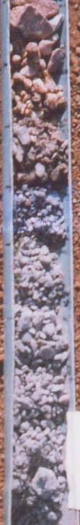
32.5-33.5 Mainly dark red with some yellow and light grey medium fairly weathered sandstone with broken rounded quartz pebbles. (Red and white conglomerate with much white quartz and brown white fine to medium quartzite very hard, some hard grey medium sandstone, odd black/brown ferrecrete nodules with red clayey to fine sand soft matrix. Some angular brown stained white vein quartz fragments)

33.5-34.5 Mostly broken rounded quartz and feldspar (?) pebbles with some weathered dark red and yellow sandstone. (broken conglomerate?)

34.5-35.6 Weathered dark grey with some red medium sandstone. Some quartz.

35.6-36.6 Very weathered dark grey with some dark red medium sandstone. Some quartz and an opaque red mineral. (jasper?)

36.6-37.6 Fairly weathered dark grey with some dark red medium sandstone.

37.6-38.6 Medium fairly weathered dark red and dark grey sandstone with some fine dark grey sandstone.

38.6-39.6 Mostly dark red with some dark grey very weathered medium sandstone. Some jasper, rounded larger quartz grains and fine grained dark red sandstone or siltstone. (Dark red brown fine to medium fairly soft friable sandstone with some black MnO₂ cement)

39.6-40.6 Fairly weathered dark grey with some dark red sandstone. Some dark red siltstone.

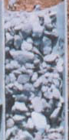

40.6-41.7 Fairly weathered dark grey and red medium sandstone. A little dark red siltstone.

41.7-42.7 Very weathered dark red and dark grey with a little light grey medium sandstone. Some fine grained dark red sandstone.

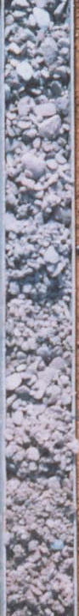
42.7-43.7 Fairly weathered dark red and light grey medium sandstone. Some dark yellow mineralisation on the red sandstone partings.

43.7-44.7 Mostly dark red fairly weathered medium and fine grained sandstone with some fairly weathered medium light grey sandstone.

44.7-45.7 Mostly dark red fairly weathered medium sandstone. A little vein quartz (Interbedded soft red brown clayey fine to medium sandstone and fairly hard platey dark brown fine to medium sandstone with some black MnO2 cement) (First water struck – 16 l/min)

45.7-46.7 Dark red fairly weathered medium sandstone. A little calcite on partings.

46.7-47.8 Slightly weathered dark red medium sandstone with clear and opaque quartz and some jasper. Some pale yellow mineral.

47.8-48.8 Fairly weathered dark red medium sandstone with some grains of a yellow mineral. (feldspar?)

48.8-49.8 Fairly weathered dark red with a little grey medium sandstone.

49.8-50.8 Fairly weathered dark red with some grey medium sandstone. A little jasper.

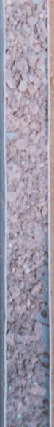

50.8 51.8 Fairly weathered dark red with some grey medium sandstone.

51.8 52.8 Fairly weathered dark red medium sandstone.

52.8 53.8 Quite highly weathered dark red medium sandstone.

53.8 54.9 Quite highly weathered dark red medium sandstone with some
weathered grey rounded siltstone.

54.9 55.9 Dark red medium to coarse grained fairly weathered
sandstone. Some quartz fragments and some opaque yellow
and pink feldspar. (feldspar?)

55.9 56.9 Moderately weathered dark red medium sandstone with some
light grey medium sandstone and some jasper. (Fairly soft
weathered silty fine to medium sandstone with some coarse
sand, friable with odd fragment of white vein quartz)

56.9 57.9 Moderately weathered dark red medium sandstone with some
light grey medium sandstone and some jasper, and a little vein
quartz.

57.9 58.9 Mostly slightly weathered dark red medium sandstone with
some vein quartz and some feldspar.
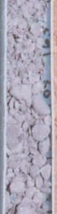

58.9 59.9 Moderately weathered dark red medium sandstone with a little
grey medium to fine sandstone.

59.9 61.0 Fairly weathered dark red medium sandstone. A little quartz
and feldspar.

61.0 62.0 Fairly weathered dark red medium sandstone with some
quartz, jasper and feldspar and a little grey siltstone.

62.0 63.0 Fairly weathered dark red medium sandstone with a few
inclusions of dark grey shale or siltstone.

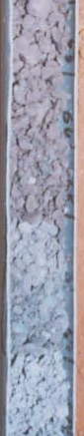

63.0 64.0 Fairly weathered dark red medium sandstone with a little
fine grained grey sandstone and feldspar.

64.0 65.0 Fairly weathered dark red medium sandstone with a little
jasper and some dark grey siltstone.

65.0 66.0 Fairly weathered dark red medium sandstone.

66.0 67.1 Fairly weathered dark grey with some dark red medium
sandstone. A little quartz and feldspar.

67.1 68.1 Fairly weathered dark grey medium sandstone with a little
quartz, jasper and feldspar.

68.1 69.1 Mostly dark grey with some dark red fairly weathered
medium sandstone.
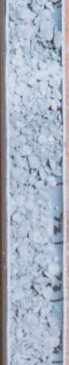

69.1 70.1 Dark grey fairly weathered medium sandstone with some
quartz, jasper and a green mineral. (feldspar?)

70.1 71.1 Dark grey fairly weathered medium sandstone with the odd
speckle of red jasper. A little dark grey fine siltstone.

71.1 72.1 Slightly weathered dark grey medium to coarse sandstone
with a little red jasper.

72.1 73.2 Fairly weathered dark grey with some dark reddish grey
medium sandstone. A little quartz and jasper.

73.2 74.2 Mostly dark grey with a little dark red fairly weathered
medium sandstone. A little quartz and jasper, and a little
dark grey siltstone.

74.2 75.2 Mostly dark grey with a little dark red fairly weathered
medium sandstone. A little quartz and jasper, and a little
dark grey siltstone. (Dark grey silty fine to coarse
sandstone soft and friable to fairly hard and blocky)
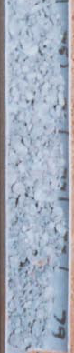

75.2 76.2 Fairly weathered dark grey medium sandstone.

76.2 77.2 Dark grey with a little dark greyish red fairly weathered
medium sandstone with a little green feldspar.

77.2 78.2 Dark grey with a little dark greyish red fairly weathered
medium sandstone with tiny fragments of jasper and quartz.

78.2 79.2 Dark grey with some dark red slightly weathered medium
sandstone with jasper, clear and opaque quartz and feldspar.

79.2 80.3 Slightly weathered dark grey with some dark red medium
sandstone.

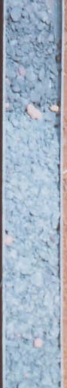

80.3 81.3 Slightly weathered dark grey medium sandstone with some
jasper.

81.3 82.3 Fairly weathered dark grey medium sandstone with some
jasper and some yellow and green feldspar. (Dark grey
fairly hard friable silty fine sandstone with white quartz
coarse sand and gravel)

82.3 83.3 Uniform slightly weathered dark bluish grey siltstone.
(shale?) (Fairly hard to hard dark grey fairly micaceous
intebedded blocky siltstone and fine sandstone)

83.3 84.3 Uniform slightly weathered dark bluish grey siltstone, with
some slatey partings. Some slightly weathered fine grained
dark bluish grey sandstone.

84.3 85.3 Dark bluish grey competent uniform siltstone. (shale?)

85.3 86.4 Dark bluish grey competent uniform siltstone. (shale? Silty
to shaley partings)

86.4 87.4 Dark bluish grey competent uniform shale. A few speckles
of mica. (Dark green grey fairly micaceous fairly soft to
fairly hard blocky to platey fine sandstone)

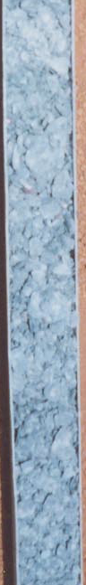

87.4 88.4 Dark bluish grey competent uniform shale and fine
sandstone. More numerous mica speckles.

88.4 89.4 Dark bluish grey competent uniform shale and fine
sandstone. More numerous mica speckles.
89.4 90.4 Competent fine grained dark grey sandstone with some
siltstone. Calcite mineralisation on partings. Speckles of
mica. Some vein quartz. (Dark grey platey to blocky fairly
soft to hard silty fine to medium sandstone some white
calcite veining) (Flow – 20 l/min)
90.4 91.4 Dark bluish grey competent fine grained sandstone.
Speckles of a white mineral (mica?). Some calcite on
fractured cleavage surfaces. (Calcite tested with acid.)

91.4 92.5 Dark bluish grey competent shale (or siltstone) with some
interlaminated fine grey sandstone. (Flow – 60 l/min)

92.5 93.5 Dark bluish grey competent fine grained sandstone with
some dark bluish grey shale. Speckles of mica.

93.5 94.5 Dark bluish grey competent fine grained sandstone.
Speckles of mica. Some finer (shaley) laminae.

94.5 95.5 Dark bluish grey competent fine grained sandstone.
Speckles of mica. Some finer (shaley) laminae.

95.5 96.5 Dark bluish grey competent fine grained sandstone with
some interlaminated shale. A little calcite. White speckles
of mica. (Or is it calcite?)
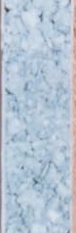
96.5 97.5 Dark bluish grey competent fine grained sandstone with
some white speckles. A little dark bluish grey shale. A
little calcite on partings. A very little quartz and jasper.

97.5 98.6 Dark bluish grey competent fine grained sandstone.
Numerous pieces of clear vein quartz, including some
crystals growing on fracture surfaces. A smaller amount of
finer grained shale. (Dark grey platey fairly hard silty fine
sandstone with some white calcite veining)

98.6 99.6 Dark bluish grey competent fine grained sandstone. Calcite
on some partings. White speckles. (calcite?) A very few
reddish bands. (Dark grey platey fairly hard silty fine
sandstone with some white calcite veining).

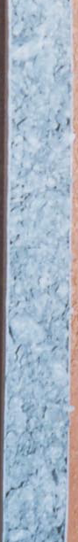

99.6 100.6 Dark bluish grey competent fine grained sandstone. A very
little calcite on some partings. White speckles. (calcite?) A
very few reddish bands.

100.6 101.6 Dark bluish grey competent fine grained sandstone. Some
finer, shaley laminae.

101.6 102.6 Dark bluish grey competent fine grained sandstone. Some
finer, shaley laminae.

102.6 103.6 Dark bluish grey competent fine grained sandstone.
Reddish discolouration on some laminae. Calcite on some
cleavage/joint planes. A little dark bluish grey competent
fine grained sandstone.

103.6 104.6 Dark bluish grey competent very fine grained sandstone.

104.6 105.7 Dark bluish grey competent siltstone.

105.7 106.7 Dark bluish grey competent siltstone with some very fine
grained sandstone. Some calcite on joint surfaces.
Cleavage slatey in places. Very many tiny speckles (mica?)
apparent when dry.

106.7 107.7 Dark bluish grey competent very fine grained sandstone.
Speckles of white calcite. A little finer grained siltstone.

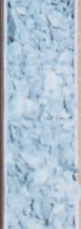

107.7 108.7 Dark bluish grey competent sandstone and siltstone. Flat,
finer grained cleavage planes in places. Calcite speckles.
(Flow – 92 l/min)

108.7 109.7 Dark bluish grey competent siltstone, slatey cleavage. (i.e.
tends to break along flat surfaces)

109.7 110.7 Dark bluish grey competent fine grained sandstone and
siltstone. Calcite speckles.

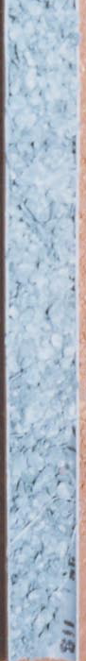

110.7 111.8 Dark bluish grey competent fine grained sandstone and
siltstone. Calcite speckles. A very little vein quartz.

111.8 112.8 Dark bluish grey competent siltstone. Some calcite and
some reddish (weathered?) layers.

112.8 113.8 Dark bluish grey competent siltstone with some very fine
grained sandstone and some mudstone. Calcite speckles.
Laminar or slatey cleavage in the finer grained material.

113.8 114.8 Dark bluish grey competent siltstone with some slatey
partings.

114.8 115.8 Dark bluish grey very fine grained sandstone and siltstone.

115.8 116.8 Dark bluish grey competent siltstone with some very fine
grained sandstone.

116.8 117.9 Dark bluish grey competent siltstone.

117.9 118.9 Dark bluish grey competent siltstone with a little (finer
grained) mudstone.

118.9 119.9 Dark bluish grey competent siltstone with a little (finer
grained) mudstone.
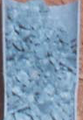

119.9 120.9 Dark bluish grey competent siltstone with a little calcite.

120.9 121.9 Dark bluish grey competent siltstone and mudstone/shale.
"Frosting" due to calcite in places.

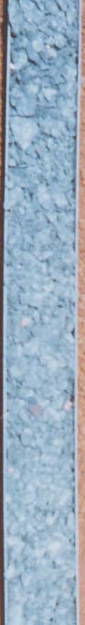

121.9 122.9 Dark bluish grey competent siltstone.

122.9 124.0 Dark bluish grey competent siltstone with some
mudstone/shale.

124.0 125.0 Dark bluish grey competent siltstone with some calcite and
a little reddish discolouration or mineralisation in places.

125.0 126.0 Dark bluish grey competent siltstone with some very fine
grained sandstone. Some calcite "frosting" and some red
discolouration.

126.0 127.0 Dark bluish grey competent siltstone with some very fine
grained sandstone.

127.0 128.0 Dark bluish grey competent siltstone with some very fine
grained sandstone.

128.0 129.0 Dark bluish grey competent siltstone with some very fine
grained sandstone.

129.0 130.0 Dark bluish grey competent siltstone with some very fine
grained sandstone with a little calcite and some red
discolouration.

130.0 131.1 Dark bluish grey competent siltstone with some very fine
grained sandstone with a little calcite and some red
discolouration.

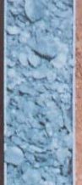

131.1 132.1 Dark bluish grey competent very fine grained sandstone
and siltstone with some calcite frosting and shaley partings

132.1 133.1 Dark bluish grey competent very fine grained sandstone
(dark grey to black hard amorphous silty fine sandstone)

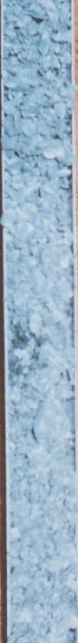

133.1 134.1 Dark bluish grey competent siltstone, mica speckles
apparent when dry, is light grey when dry

134.1 135.1 Dark bluish grey (light grey when dry) very fine grained
competent sandstone to siltstone, massive rather than platey
cleavage, calcite frosting, mica speckles when dry

135.1 136.1 Dark bluish grey (light grey when dry) very fine grained
competent sandstone to siltstone, some platey cleavage,
calcite frosting, mica speckles when dry
(Flow – 130 l/min)
136.1 137.2 Dark bluish grey fairly competent to competent very fine
grained sandstone and shale, some platey partings with
speckles of calcite and some mica

137.2 138.2 Dark bluish grey competent very fine grained sandstone to
siltstone, some shaley partings, calcite and some mica

138.2 139.2 Dark bluish grey competent very fine grained sandstone to
siltstone, some shaley partings, calcite and some mica

139.2 140.2 Dark bluish grey competent very fine grained sandstone to
siltstone, some calcite frosting sometimes in bands, much
small micas

140.2 141.2 Dark bluish grey hard competent very fine grained
sandstone to siltstone, some calcite frosting, massive in
parts, otherwise platey

141.2 142.2 Dark bluish grey competent very fine grained sandstone,
some calcite discolouration (frosting), many speckles of
mica (Dark green grey to black fairly hard to hard silty fine
sandstone)

142.2 143.3 Dark bluish grey competent very fine grained sandstone,
some calcite discolouration (frosting), many speckles of
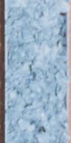
mica

143.3 144.3 Dark bluish grey competent siltstone, sometimes massive or
shaley/platey, some dark red discolouration, calcite frosting
and mica speckles

144.3 145.3 Dark bluish grey competent very fine grained sandstone,
some calcite frosting and dark red discolouration

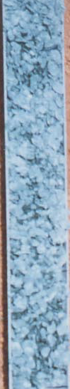

145.3 146.3 Dark bluish grey competent very fine grained sandstone to
siltstone, some calcite and mica speckles

146.3 147.3 Dark bluish grey competent very fine grained sandstone to
siltstone, mica speckles, some cloudy calcite, mainly
massive

147.3 148.3 Dark bluish grey competent very fine grained sandstone to
siltstone, mica speckles, some cloudy calcite, mainly
massive

148.3 149.4 Dark bluish grey competent very fine grained sandstone to
siltstone, some calcite frosting and mica speckles (Dark
grey black fairly hard to hard silty fine sandstone)

149.4 150.4 Dark bluish grey competent very fine grained sandstone,
slightly coarser, some calcite and red discolouration with
mica speckles

150.4 151.4 Dark bluish grey competent siltstone, a little calcite in
spots, some mica speckles

151.4 152.4 Dark bluish grey competent siltstone, a little calcite in
spots, some mica speckles (Dark grey black very hard
quartzitic silty fine sandstone)

